Artist Statement – Assia Sabri
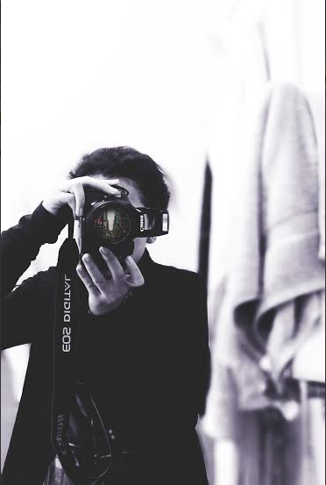
Through the photos I have captured, many were black and white which was chosen for my theme. When people look at a black and white photograph, they often remark how "classic" and "elegant" it looks. But in my photos they show scenery and and hints of the outside world. Black and white photos often show simplicity and have some sort of quality that pops out a certain center focus. In my photos I am trying to say that one must have a different viewpoint of the world to fully see a different story. Some things just look better when shot in black and white. What might appear boring when shot in color suddenly becomes fascinating when captured in black and white which is why it is the most liked effect for me. Black and white focuses the attention on form, shading, pattern, and other graphic concepts, to give them an unusual quality with tone and hue. They make shadows appear more visible and bring out almost every detail in a photo. I like photography because it allows you to express your artisitic side and gives you more power behind the lens. Photography also made me change the way I see humanity. Many people can walk by and you would not know their story but if you capture them, it can say a lot. The way they pose, act, and dress for a shot can say more than verbally communicating to a stranger. I now see beauty in my everyday surroundings. Colors became brighter, lines vivid and splendor in the eyes of everyone. It has helped me to take a step back and breathe in the world, rather than charging ahead and missing it all. Photography is just a new strength that helps me let out my voice.

