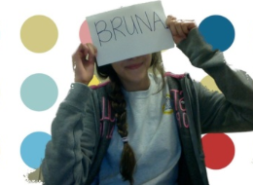

Bruna Parreira
The images in my photo story have many forms of compositions. Some have color contrast making the white and black pop out to the eye. Other photos have the rule of thirds like the picture of the girl and the horse – the girl is on the bottom right corner of the frame. Another composition element used is lines. There are different kinds of lines like parallel, horizontal, and vertical lines. These lines make up the picture and direct the viewers eye to a specific focal point.

I have captured the people that roam through New York City. Many exotic people are in New York, each and every group of people have different backgrounds and stories of their own. Through photography, emotions and meanings can affect an individual in many ways. This medium it is the best way to capture vivid moments in life and make them memorable. When capturing my images I was influenced by Angel, a photographer we met. After looking at Angel’s portfolio I was driven to explore New York and the unique people in it. Angel captures beautiful moments of people in New York. He took pictures of people without them noticing which created a raw image of people in their element.

