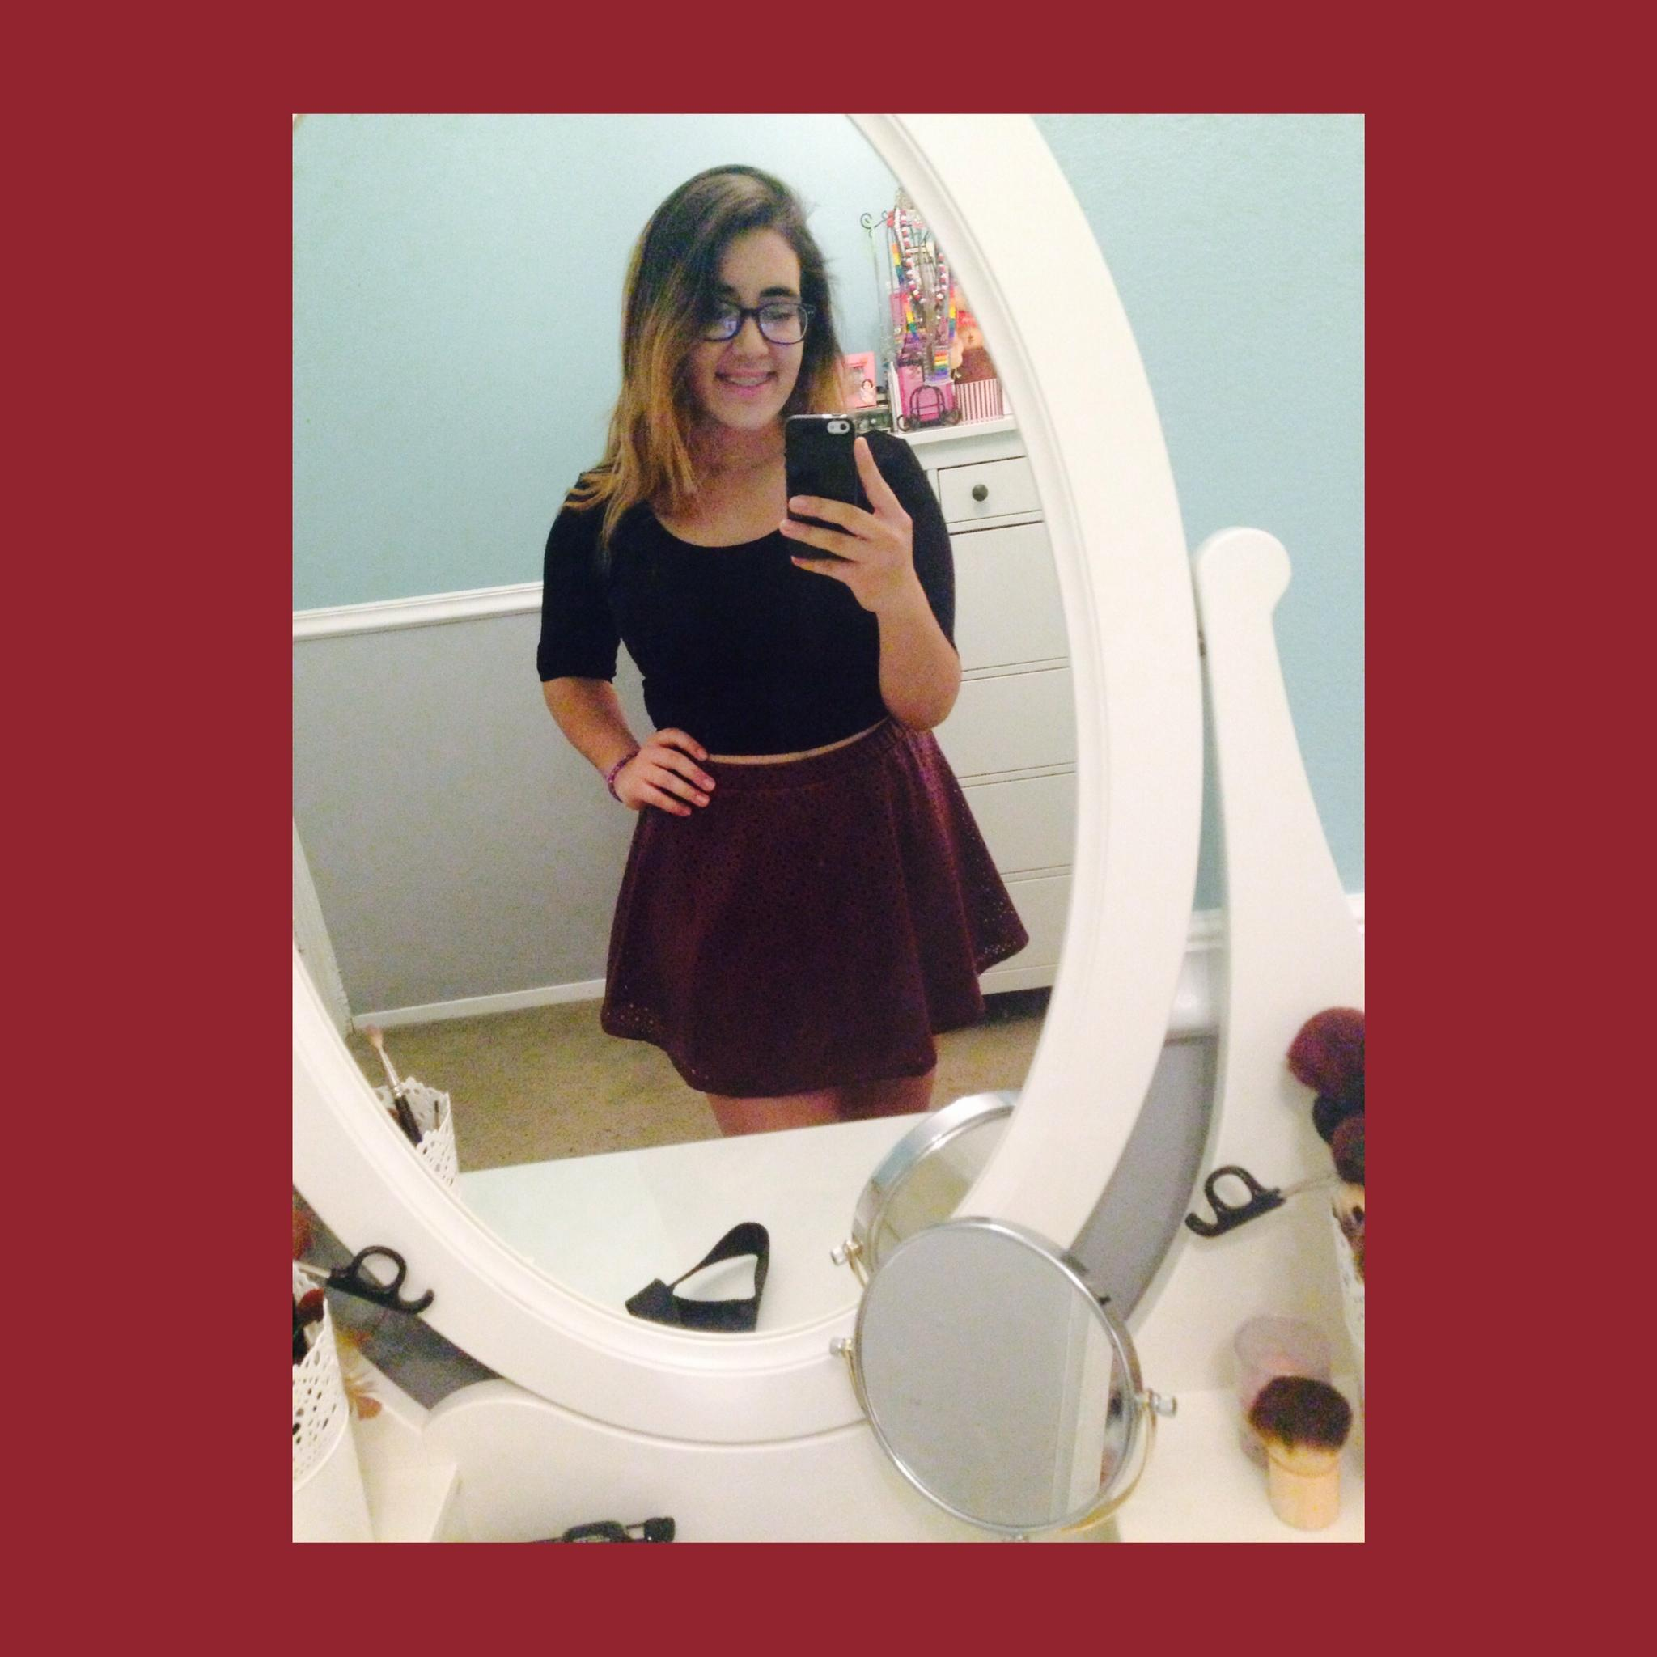
Daniela Doyle
The images displayed are things that I have seen through these two weeks during my photography project. These images all have something in them that doesn’t exactly belong, “Misplaced”. I saw these objects in random places, such as, a pile of leaves, under a park bench, or in the city.. Through my pictures I want to show that in every picture there is something out of place. Even though there are items out of place in these pictures I feel that they make the picture, they complete it. The ‘misplaced’ items in these pictures show imperfection within them. Through these two weeks when I took these photos I saw the beauty in imperfection and thats what I would like my observers to see. I’m trying to portray the message of nothing is perfect, yet there is a beauty in everything. I feel that the imperfections in these pictures are the best things about them. I feel that my pictures send a message to this society and generation due to the fact that everyone sees the worst in themselves and each other, I feel that portraying this message will help society understand that beauty is imperfection. In my photos I like to use leading lines, rule of thirds, patterns, different angles, etc, to bring out the “imperfection” in my pictures. I’ve always enjoyed photography, but I have learned new and better ways to take pictures and I feel that I have different “eyes” because I find pictures everywhere.

